5D4N HANOI – HALONG – HOCHIMINH – CUCHI

DAY 1: HANOI – ARRIVAL ( D )
Upon arrival at Noi Bai International airport, transfer to Hanoi downtown to visit the West Lake, Tran Quoc Pagoda, Hoan Kiem Lake (Restored Sword Lake ) and shopping at 36 Old Quarter, enjoy Water Puppet Show.

Meals: 1 Dinner
Accommodation: Overnight in Hanoi.
The distance: Noi Bai Airport – Hanoi Capital: 35km – 45 minutes for transfer.

DAY 2: HANOI – HALONG ( B/L/D)
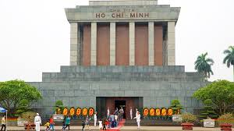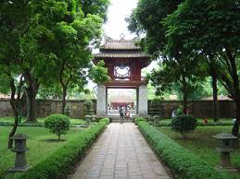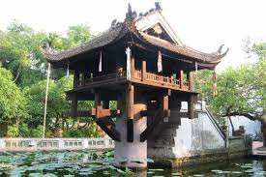
Ho Chi Minh Mausoleum Temple Of Literature One Pillar Pagoda
Breakfast at hotel, Starting city tours with Ho Chi Minh Mausoleum, Ho Chi Minh Palace, Ba Dinh Square, Uncle Ho' Stilt House, One Pillar Pagoda, Temple Of Literature, Hoan Kiem Lake ( Restored Sword Lake ) and shopping at 36 Old Quarter. After lunch, transfer to Halong Bay - a UNESCO World Heritage site (160km driving one way - 3.5hrs drive). This will be your first opportunity to see some of the rural areas of Vietnam. The drive goes through the Red River delta, so we'll have plenty of chance for taking photo of Vietnamese farmers tilling the vast green paddy field. Arrival Halong, check in hotel for leisure. Dinner and overnight in Halong Bay.

Meals: 1 Breakfast + 1 Lunch + 1 Dinner
Accommodation: Overnight in Halong
The distance: Hanoi - Halong: 160km – 4 hours for transfer.
DAY 3: HALONG – HANOI - HOCHIMINH (B/L/D) ( Flight Booked By Yourself )
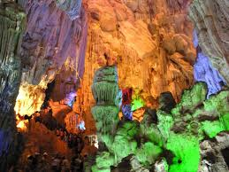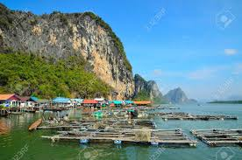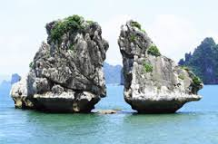
Paradise Grotto Fisherman Village Kissing Chicken Rock
After breakfast, transfer to Halong Boat station to take our private boat to visit the world Heritage Halong Bay about 4 hours, our boat will bring us to visit Paradise Grotto, Kissing Chicken Rock, Fisherman Village, lunch will be served with fresh Halong Seafood, enjoy Vietnam Coffee on Cruise. Transfer to airport for take flight to Hochiminh City ( Saigon ). Overnight in Hochiminh City.

Meals: 1 Breakfast + 1 Lunch + 1 Dinner
Accommodation: Overnight in Saigon
The distance: Halong - Hanoi: 160km – 4 hours for transfer.
DAY 4: HO CHI MINH – CU CHI (B/L/D)
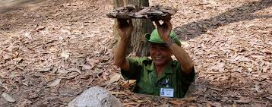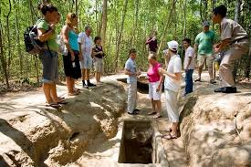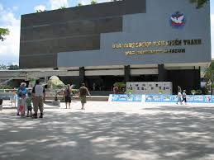
Cu Chi Tunnels War Museum
After breakfast, proceed to Cu Chi Tunnels – a network of tunnels more than 200km long and 3 – 8 m deep, dug during the warfare days and is about 75km north west of the city, back to Ho Chi Minh. After lunch, visit War Museum, vist The Hundreds Years Red Cathedral, Old Post Office, The People’s Committee Hall, French Opera House, Ben Thanh Market. Dinner will be served on Saigon River Cruise with show entertainment along the Saigon River at the end of the day. Overnight in Hochiminh City.

Meals: 1 Breakfast + 1 Lunch + 1 Dinner
Accommodation: Overnight in Saigon
The distance: Saigon – Cu Chi: 75km – 2 hours for transfer.
DAY 5: HO CHI MINH DEPARTURE (B)
After breakfast, free at leisure then transfer to Airport for flight home with sweet memories.

Meals: 1 Breakfast
The Ends of services!!!!

SEQUENCE OF ITINERARY SUBJECT TO LOCAL ARRANGEMENT
PRICE INCLUDE:
- Accommodation – as hotel in the list or similar – based on Twin/Double/Triple sharing
- Tour guide: English or Chinese speaking guide during the tour.
- Daily ABF and meals as mentioned in the program
- Shows and sightseeing in schedule.
- Transportation by private air-conditioner.
01 bottle ( 500 ml )of drinking water for each pax per day.
- Meals (Vietnamese Food & Chinese Food) as the tour code ( B: Breakfast, L: Lunch, D: Dinner) 8-10 USD/meal/pax + 01 Dinner at Saigon Cruise
- Free coke/beer/coffee/water on Halong Cruise.
- Boat fees private one in Halong as mentioned in the program.
PRICE EXCLUDE:
- International / Domestic flight ticket & airport tax (if have)
- Personal expenses: Tel, Fax, Mini Bar, Laundry,etc.
- Personal travel insurance
- Compulsory Tip for local guide and driver (USD/pax/day)

Group Size | Tips in USD
2 – 4pax | 6
5-7pax | 5
8 - up | 3

- Additional Meal will be surcharge 10usd/pax/meal.
- Surcharge with other languages guide
- Surcharge at hotel case by case
  - Chinese New Year (TBA)
  - Gala Dinner on X’Mas (24, 25 Dec ) & New Year 31 Dec.

Hotel category  Hotel listed or Similar |  |  | All rates are next in USD/PAX  valid Jan - Dec, 2020
 |  |  | Tour by private car / bus with private guide
HANOI | HALONG | HOCHIMINH | 2 | 3-4 | 5-6 | 7-9 | 10-15 | 15+1 | 20+1 | 25+1 | 30+1 | SS
Larosa 3*  Pomihoa 3*  First Eden 3*  Thang Long Espana 3*  Adamas 3*  Authentic 3* | Seastar 3*  Golden Bay Ha Long 3*  Sen Hotel 3* | Le Duy 3*  Bloom Saigon 3*  Alagon Western 3*  Ambassador 3*  Aluna 3* | 461 | 385 | 316 | 283 | 270 | 256 | 246 | 233 | 226 | 80
Thang Long Opera 4*  Chalcedony 4  Hotel Kuretakeso 4*  Lan Vien 4* | Galaxy Ha Long 4*  Au Lac 4*  Mithrin 4*  Song Loc 4* | MuongThanh 4*  Palace Saigon 4*  Athena Saigon 4*  Cicilia 4* | 486 | 411 | 341 | 309 | 296 | 281 | 273 | 258 | 253 | 105

NOTE

The timing of sightseeing points shall be fixing by local operator due to traffic and weather conditions, however all points must cover unless amendment or cancellation make by clients themselves (Non-refundable for any cancellation that made by clients)

Tour and price are subject to change without notice or incase of deduct number of pax in quoted group.

Small deviations in the tour program are sometimes necessary, depending on weather, road conditions, flight schedules and room availability.

Supplement charge for room rate in peak dates depends on the hotel category used. Compulsory gala dinner on X’mas, New Year’s Eve & Lunar New Year’s Eve to be advised upon booking. Prices for group of 15 persons up in 5 stars hotels sometime requires to re-quote bases on the hotel policy

Group tour of full paying 16pax, one (01) tour leader is given complimentary on twin sharing basis include breakfast (domestic air ticket is not applicable)

BUS

Group Size | Kind of Transportation
1-2 pax | 4 seater
3 pax | 7 seater
4-9pax | 16 seater
10-14 pax | 30 seater
15-22 pax | 35 seater
23 – 42 pax | 45 seater

OPTIONAL INFO:

1/ Trishaw to visit 36 old quarters 10 USD/1 pax/ 1 trishaw.
2/ Vietnamese traditional massage in Halong bay: 1h30 minutes including tips: 20 USD/ pax.

- Commisstion 10% for tour leader

SHOPPING INFO:

1/ Vietnam local products
2/ Duty free jewelry center

- Commision 5% for Tour Leader

Tour request without shopping and no options will be surcharge 10USD/pax.

CHILD POLICY

- Infant below 2 years old sharing same room with parents is free of charge.
- Child below 12 yrs old sharing same room with 1 ADL is charged for 90%.
- Child below 12 yrs old with extra bed and sharing same room with parents is charged for 65%.
- Child below 12 yrs old No extra bed & sharing same room with parents is charged for 55%.

